# Problem Solving Assignment

**Problem 1: *A Cat, a Parrot, and a Bag of Seed***

1. Define the problem: This problem consists of getting a man, a cat, a bird and a bag with just one seed and this man has a boat that needs to cross a river. But the man can only carry one other thing in his boat while he crosses the river. The cat could eat the bird, and the bird could eat the seed. So he needs to cross them over in a specific way that one doesn’t eat the other.  
   Insight: The problem says it’s a bag of seed, which leads me to think there’s only one seed in the bag, but I’m not sure.  
   Purpose: The main goal is to get all 3 and man across the river, whole and/or alive.
2. Constraints: You cannot leave the bird alone with the cat or the bird alone with the seed.  
   Sub-goals: take each one across the river without having one eat the other while left alone.
3. Potential Solutions: At first I thought a possible solution to the whole problem was the bird eat the seed and the cat eat the bird and then technically you could get everything across the river but then after I read the whole problem, it was obvious this couldn’t be a solution.   
   A solution to make sure one thing doesn’t eat the other is to take the things across the river in an order that no one would eat anything. Possibly taking things back and forth until you’re able to get everything across.
4. Evaluate Solutions: Well my first solution wouldn’t work because it defeats the purpose of crossing everything over the river alive.  
   The second solution could work to eventually solve the whole problem and achieve the main goal of crossing everything over in one piece while doing one at a time.
5. Choose Solution & Develop Plan: The theorized solution I evaluated in part four, does in fact work. Follow along with the diagram below.
   1. Step 1: The man, cat, parrot, and seed all start off in the same side of the river.
   2. Step 2: The man takes the parrot across the river.
   3. Step 3: The man crosses the back to the original side of the river and leaves the parrot on the other side.
   4. Step 4: The man takes the seed to the other side of the river while leaving the cat on the original side of the river.
   5. Step 5: The man takes the parrot with him to the original side of the river and leaves the seed on the other side.
   6. Step 6: The man takes the cat to the other side of the river, where the seed is, and leaves the parrot on the original side of the river.
   7. Step 7: The man crosses back to the original side of the river. The parrot is on the original side while the cat and the seed are on the other side.
   8. Step 8: The man lastly takes the parrot to the other side of the river.

Following these steps the man can take everything across the river and nothing will get eaten.  
  
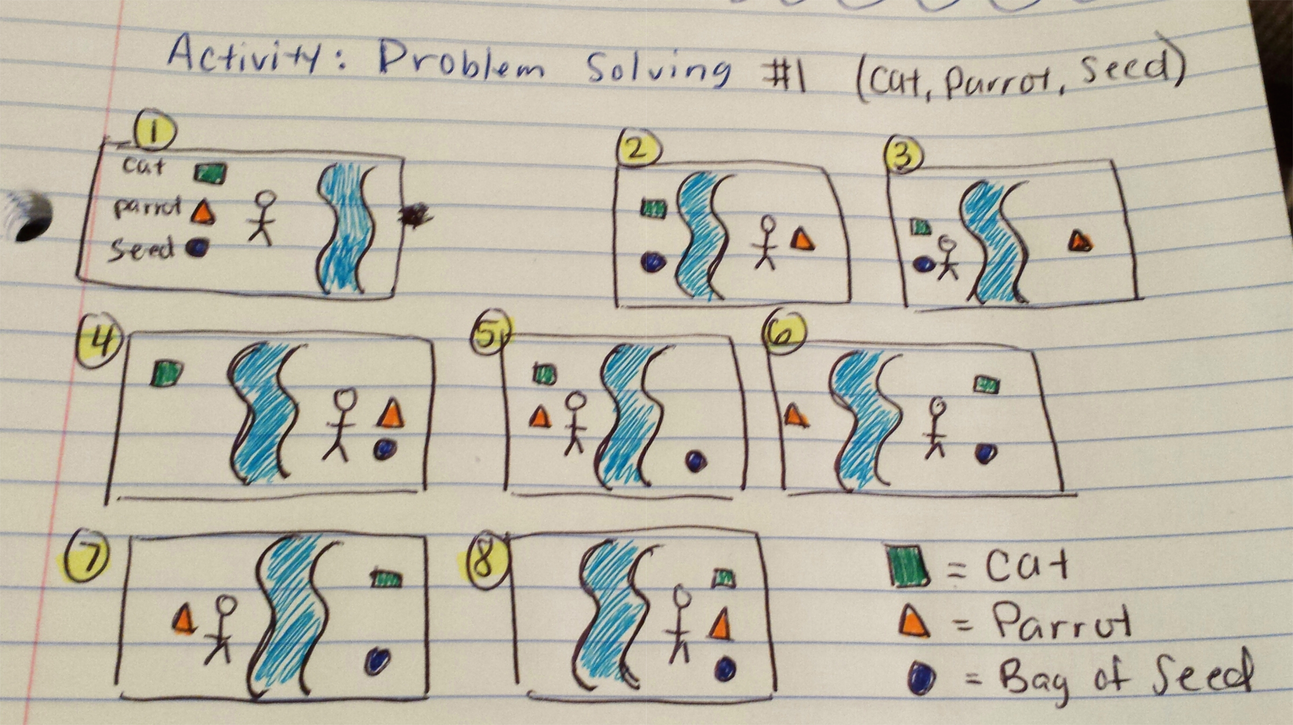

**Problem 2: *Socks in the Dark***

1. Define the problem: This is a probability problem about selecting socks from a drawer. There are 20 individual socks in a drawer; where 5 pairs (10 individuals) are black socks, 3 pairs (6 individuals) are brown socks and 2 pairs (4 individuals) are white socks.  
   Insight: I believe what’s missing from this problem is how many times you actually reach into the drawer to grab socks.   
   Purpose: The main goal is to figure out how many is the least possible amount of socks you can grab to get one matching pair of socks and/or one matching pair of each of the 3 colors of the socks.
2. Constraints: Not knowing how many times you actually reach into the drawer. This is missing data. I could grab socks, but how many socks am I grabbing in how many times?  
   Sub-goals: Possibly solve one sock color probability at a time.
3. Potential Solutions: Not exactly sure as to how to solve the problem
4. Evaluate Solutions: Not exactly sure as to how to solve the problem
5. Choose Solution & Develop Plan: Not exactly sure as to how to solve the problem  
     
   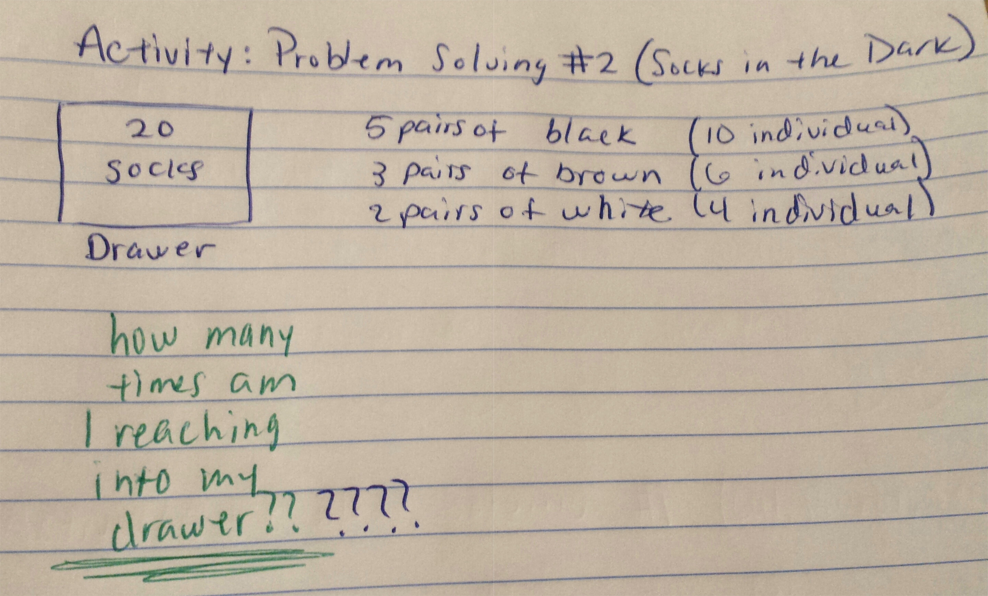

**Problem 3: *Predicting Fingers***

1. Define the problem: There’s a little girl who wants to count using her fingers. But the girl doesn’t use both her hands; she only uses her left hand. Instead if counting her fingers in chronological order (for ex: thumb, first finger, middle finger, ring finger, little finger and repeat this order again to keep counting), she does a back and forth motion to count her fingers (for ex: thumb, first finger, middle finger, ring finger, little finger, back to ring, middle, first, thumb, first, middle, ring, little, etc.).  
   Insight: Something you don’t notice from the beginning is that by only using one hand to count (5 fingers, odd number) and not going in chronological order it’s hard to tell which finger you’ll actually land on because it seems it’ll be a different finger each time.  
   Purpose: The main goal is to know which finger she will land on if she counts up to certain numbers.
2. Constraints: The main constraint is that the girl is only counting with one hand and going back and forth between fingers.   
   Sub-goals: I would say a primary sub-goal is to see if there’s a pattern when counting to then help figure out which finger gets landed on when counting.
3. Potential Solutions: Count up to 50 using your own hand to see if there is a pattern. Then apply it to counting to hire numbers.
4. Evaluate Solutions: This solution can most definitely identify a repetitive pattern to take note up when wanting to count to either 10, 100, or 1000. Using a sheet of paper to write down your patter order also helps to remember. Method: When you first count up to 10, you land on the first finger. When you count up to 20, you land on the ring finger. When you count up to 30, you land on the ring finger. When you count up to 40, you land on the first finger. When you count up to 50, you land on the first finger.  
     
   This pattern actually leads to another pattern.. for every hundred-counts the landing finger goes by one instead of two now. Meaning, when you land on 100, you get the ring finger. When you land on 200, you get the first finger. When you land on 300, you get the ring finger. When you land on 400 you get the first finger, etc. etc.
5. Choose Solution & Develop Plan: The pattern first begins with the first finger but then leads to the next two ten-counts to land on the ring finger. The following two ten-counts land on the first finger, etc. etc. And by hundred counts you only switch off once by the first/ring finger instead of twice.   
     
   Therefore, when you count to 10, you land on the first finger. When you count to 100, you land on the ring finger. And lastly, when you count to 1000, you land on the first finger.   
     
   